# **UNIT 1 : BACK TO SCHOOL** (cont.)

**Period 4 ( A3 + A5)**

### 3. Listen. Then practice with a partner. (p.12)

Look at the picture. T*his is Nga, a new student, and this is Mr. Tan, a teacher .*

*Nga meets Mr.Tan in the morning. Listen to the dialogue between Nga and Mr. Tan .* What does Nga say to her teacher when she meets him ?

* **Nga :** Good morning, Mr. Tan.
* **Mr. Tan :** Good morning, Nga. How are you?
* **Ba :** I’m very well, thank you. And you?
* **Mr. Tan :** I’m fine, thanks. Good bye. See you later.
* **Nga :** Goodbye.

**Vocabulary:**

* hurry (v) /h ʌ ri/ : vội vàng

*Ex.: Don’t hurry, there is a lot of time.*

* hurry (n) : sự vội vàng

*Ex.: Is there any hurry?*

* ready (adj.) /’redi/ : sẵn sàng

= prepared

= available

*Good morning/afternoon/evening: dùng để chào người lớn tuổi hơn khi gặp vào các buổi tương ứng.

*Hi/Hello: dùng để chào trong những trường hợp thân mật (bạn bè).

**5. Listen. Write the letters of the dialogues in the order you hear (p.13)**

***Look******at the 4 pictures and tell me :***

* ***Where are they ?***
* ***What do you think they will say ?***

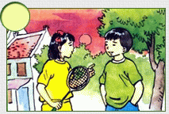

**b)**

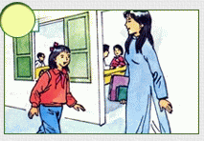

**c)**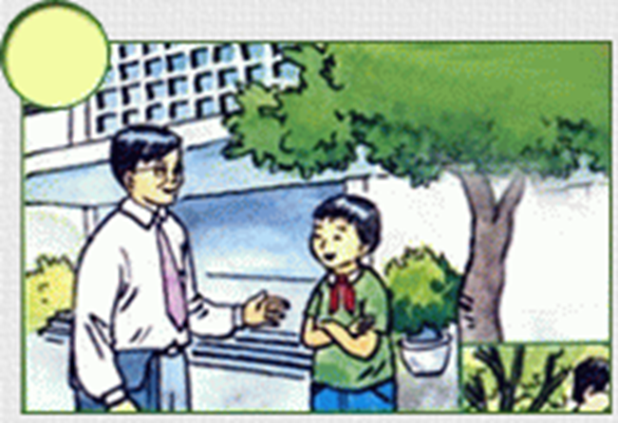

**d)**

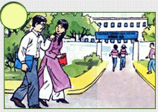

**Now, listen to the 4 conversations and write the number in the order you hear.**